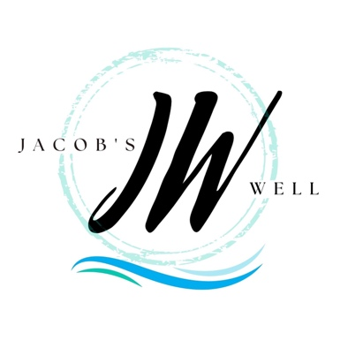 | MINISTRY COVENANT
Mission: ALL Making Disciples of ALL
Strategy: Worship, Learn, Serve, Play
Core Values: Word, Discipleship, Honesty, Kindness, Service, Community

Our mission of ALL making disciples of ALL is accomplished as we worship, learn, serve, and play together. Your contribution of service on the Hospitality Team is vital to the fulfillment of the mission of the church. As a Server, Communion Preparer, Decorator, Kitchen Helper, or Equipment Crew member, you facilitate “play” and fellowship for guests and members.

MINISTRY TEAM: Hospitality Team

ROLE: Servers, Communion Preparer, Decorators, Kitchen Helpers, Equipment Crew*

GOAL: To facilitate fellowship, hospitality, and “play” for the whole church

DIRECT REPORT: Hospitality Team Coordinator

PASTORAL TEAM LEADER: Arash Ahmadpour

POSITION REQUIREMENTS:
- Must have completed new members classes (Discovering Jacob’s Well)
- Must have completed level 1 discipleship classes (A New Life)
- Must be an example of a growing Christian
- Must be faithful in attendance to church services and a small group
- Must be dependable
- Must be friendly, creative, energetic, and able to anticipate the needs of guests and members

JOB DESCRIPTIONS & RESPONSIBILITIES (Potlucks, Repasts, Special events, etc.)
- Set-up and breakdown equipment (tables, chairs, etc.)*
- Decorate facilities according to the nature of the event
- Manage food and drinks
- Clean and organize kitchen following events
- Serve guests and members as appropriate
- Prepare Communion (bake bread and fill communion trays)
- Other duties as assigned

TIME REQUIREMENT:
- Potlucks: Approximately 4 hours, quarterly (Pre, during, and post event)
- Repasts: As required
- Communion prep: Approximately 1 hour
- Other events: As required

In the spirit of our core values, I understand my role of responsibility and commit to fulfill this ministry covenant in service to God and to the body of Christ.

_____________________________ __________________________ ____________________
Covenant Member Signature Print Name Date

_____________________________ __________________________ ____________________
Pastoral Team Member Signature Print Name Date

